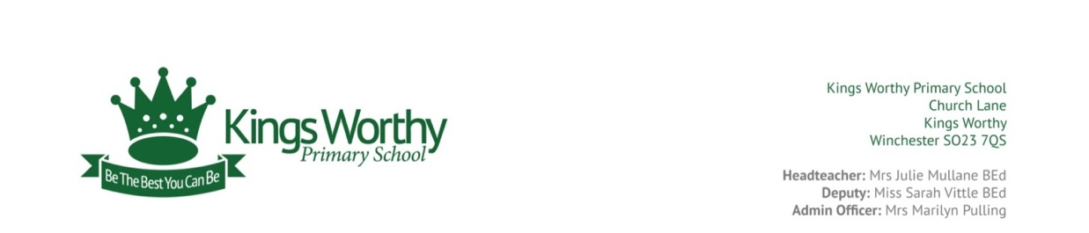

**Reading Rainbow**

**How much of this Reading Rainbow can you complete this week?**